# *Assignment 2 – From Use Case to Class Design*

Date assigned: Monday, March 6, 2017

Date due: **Wednesday, March 15, 2017 11:50pm**

**Learning Objectives**

Upon successful completion of this assignment, the student will be able to:

* Analyze Use Cases and generate Activity Diagrams
* Design Classes that address the application covered in the Activity Diagrams
* Draw Class Diagrams
* Draw Sequence Diagram

Assignment Set Up

1. This is a mix of team and individual work. Part A, B, are teamwork. Part C is individual.
2. See class slides from “Use Case Analysis” in Moodle for reference on identifying objects.
3. See class slides from “Class Diagrams / CRC” in Moodle for reference on the CRC exercise.
4. Enter your team members in the table below:

|  |  |
| --- | --- |
| Alexander Beeftink |  |
| Jeremy Clarke |  |
| Philip Dumaresq |  |

# Part A – Use Case Analysis and generation of Activities

1. Consider the simple online shopping use case below:

Provide the text steps for each use case. (10 in all). Starting assumption is that the user is already logged on (authenticated) and is viewing a home page. See Appendix A for further notes.

External Actors:

|  |  |
| --- | --- |
|  |  |
| Warehouse | Inform to make item ready |
| Payment System | Get funds |
| Shipping | Deliver product |



|  |  |
| --- | --- |
| Use case: Browse Catalog | |
| Step # | Action |
| 1 | The use case begins when user selects catalog subject. |
| 2 | System retrieves data on catalog subject. |
| 3 | System displays data to user. |

|  |  |
| --- | --- |
| Use case: View Shopping Cart | |
| Step # | Action |
| 1 | The use case begins when user selects the View Shopping Cart icon. |
| 2 | The system retrieves the shopping cart information. |
| 3 | The system displays the shopping cart. |

|  |  |
| --- | --- |
| Use case: View Order | |
| Step # | Action |
| 1 | The use case begins when chooses the view order option. |
| 2 | The system verifies that there is an order. |
| 3 | The system displays current order. |

|  |  |
| --- | --- |
| Use case: Provide Ratings | |
| Step # | Action |
| 1 | The use case begins when user selects ratings option. |
| 2 | The system verifies that user is registered. |
| 3 | The system displays the rating options. |
| 4 | The user selects the ratings on the options. |
| 5 | The user submits selections. |
| 6 | The system records user selections. |

|  |  |
| --- | --- |
| Use case: Write Reviews | |
| Step # | Action |
| 1 | The use case begins when the user wants to write a review. |
| 2 | User selects review option. |
| 3 | The system verifies that the user is registered. |
| 4 | The system displays the Write Review page. |
| 5 | The user writes a review. |
| 6 | The user submits review. |
| 7 | The system records the review. |

|  |  |
| --- | --- |
| Use case: View Details extends Browse Catalog | |
| Step # | Action |
| 1 | The use case begins when the user selects an item. |
| 2 | The system gets data on the item selected. |
| 3 | The system displays the details of the item. |

|  |  |
| --- | --- |
| Use case: Update Shopping Cart extends View Shopping Cart | |
| Step # | Action |
| 1 | The use case begins when the user selects their shopping cart. |
| 2 | The system retrieves the user’s shopping cart information. |
| 3 | The user makes changes to item quantities or deletes item. |
| 4 | The system updates shopping cart information. |

|  |  |
| --- | --- |
| Use case: Checkout extends View Shopping Cart | |
| Step # | Action |
| 1 | The use case begins when the user select the checkout option. |
| 2 | The system retrieves the shopping cart information. |
| 3 | The system displays the shopping cart information, prices and total. |
| 4 | The user selects the purchase option. |
| 5 | The system checks inventory with Warehouse. |
| 6 | Warehouse reports if order can be filled. |
| 7 | The system checks with the payment system that user can pay. |
| 8 | The system updates warehouse about order. |
| 9 | Warehouse assembles order. |
| 10 | Warehouse informs system that order is assembled. |
| 11 | Warehouse arranges shipping. |
| 12 | Warehouse informs system that order is shipped. |
| 13 | The system gives user conformation of status of order. |
| 14 | The system emails user with invoice. |
| 15 | The user pays invoice. |
| 16 | The system emails user with receipt. |

|  |  |
| --- | --- |
| Use case: Cancel Order | |
| Step # | Action |
| 1 | The use case begins when the user chooses to cancel their order. |
| 2 | The system checks if the order is already in progress. |
| 3 | The system clears the shopping cart. |
| 4 | The system returns the user to the home page. |

|  |  |
| --- | --- |
| Use case: Add to Shopping Cart | |
| Step # | Action |
| 1 | The use case begins when the user selects an item to add to cart. |
| 2 | The system adds item to cart. |

1. Create Activity Diagrams (no swim lanes) for the following and paste them below. :
2. Customer browses catalog, selects an item, views details and adds it to the shopping cart.

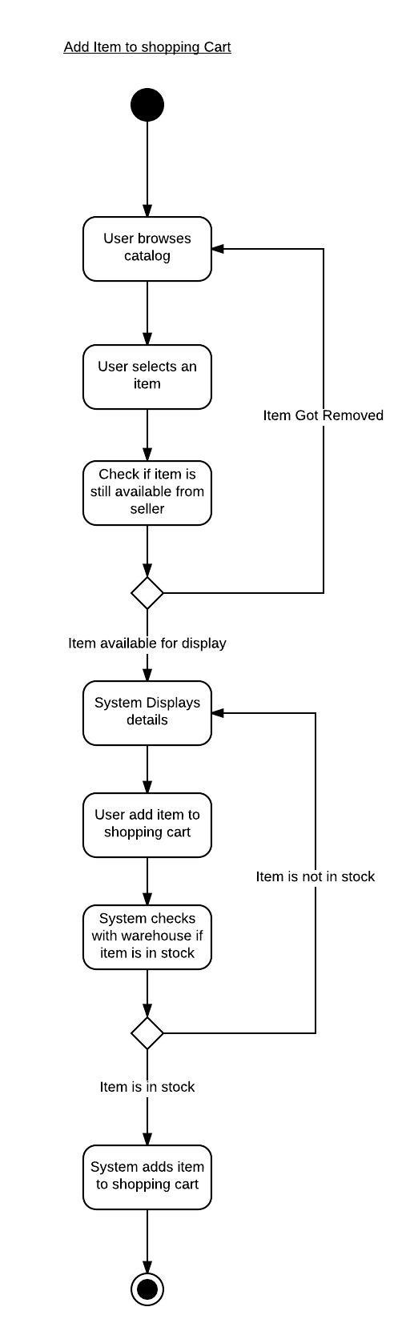

1. Customer views cart, removes an item from the cart, then checks out.

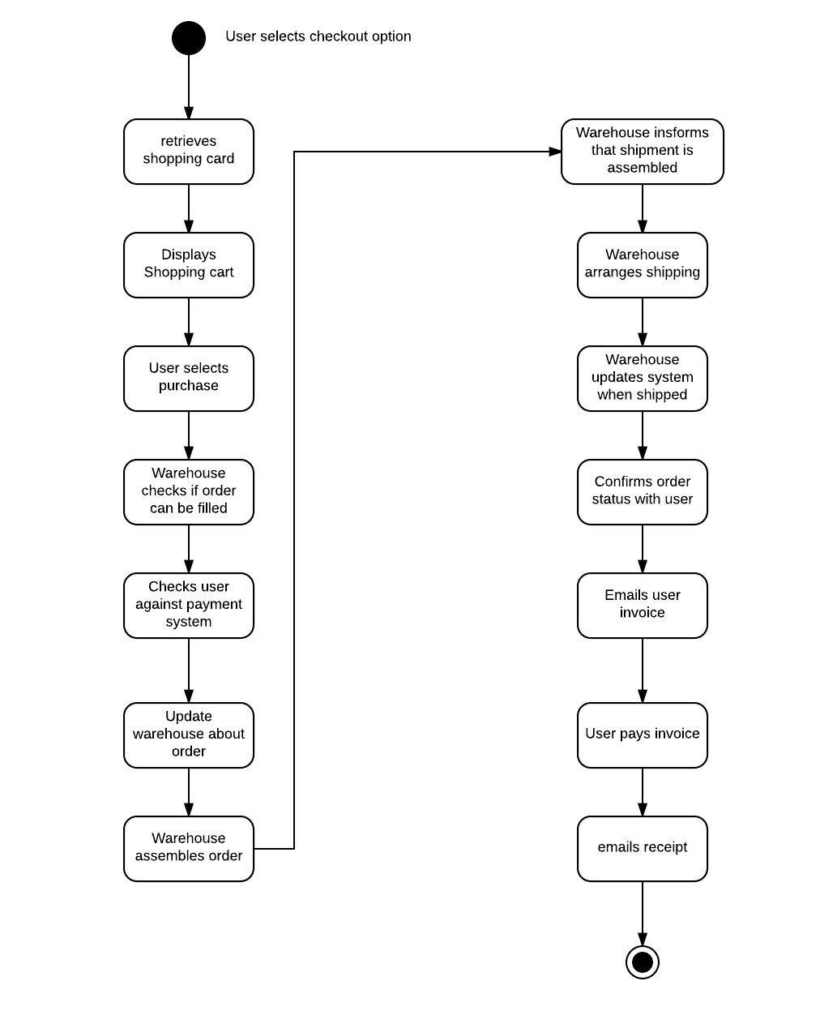

1. Customer views orders, selects an order and cancels the order.

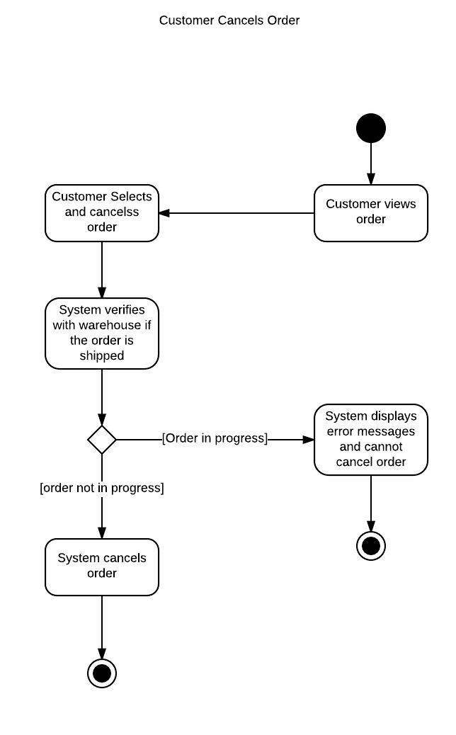

1. Add swimlanes to the diagrams above. Paste them below:

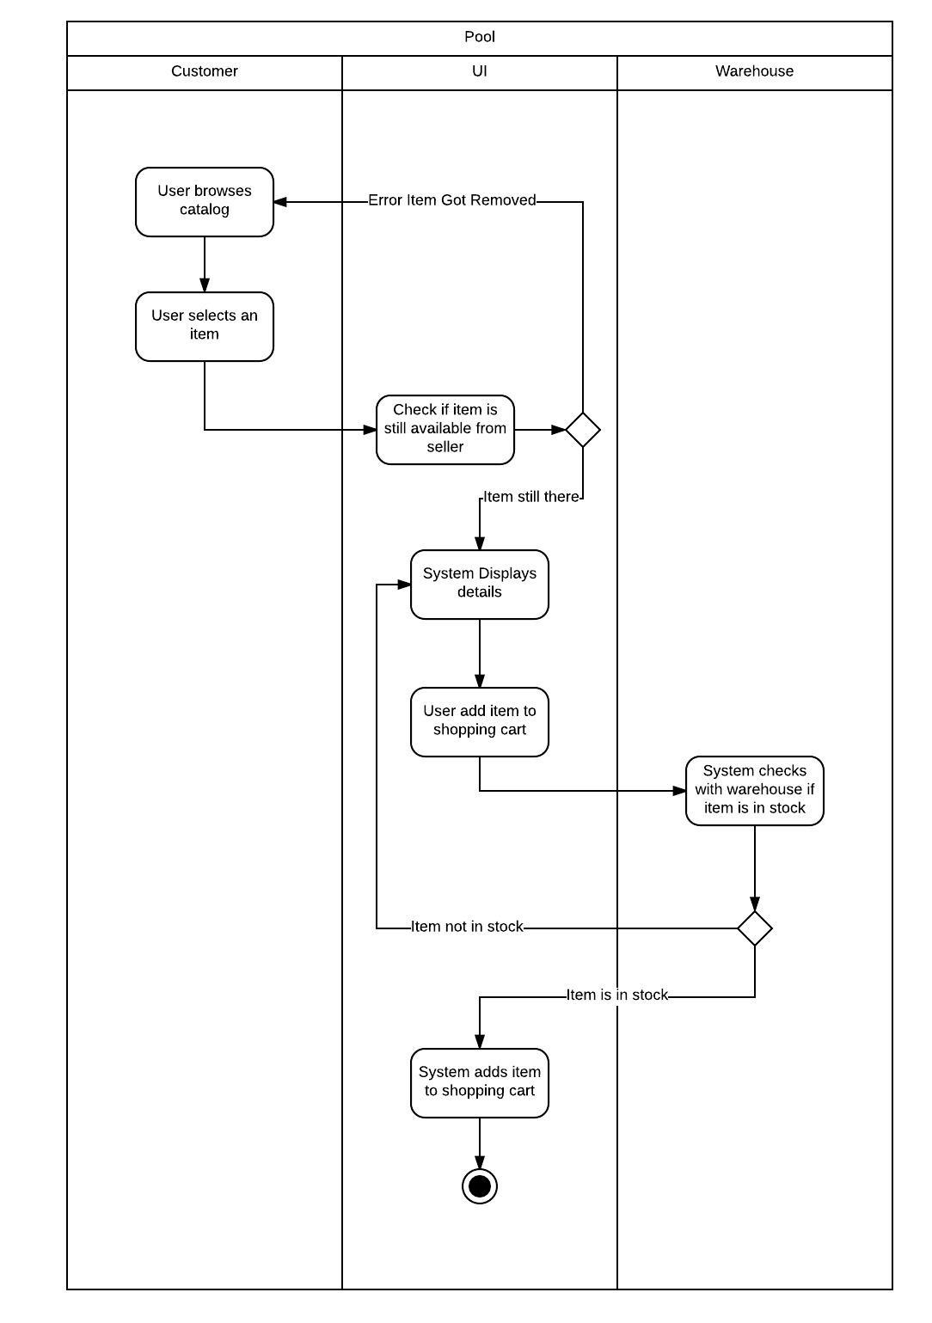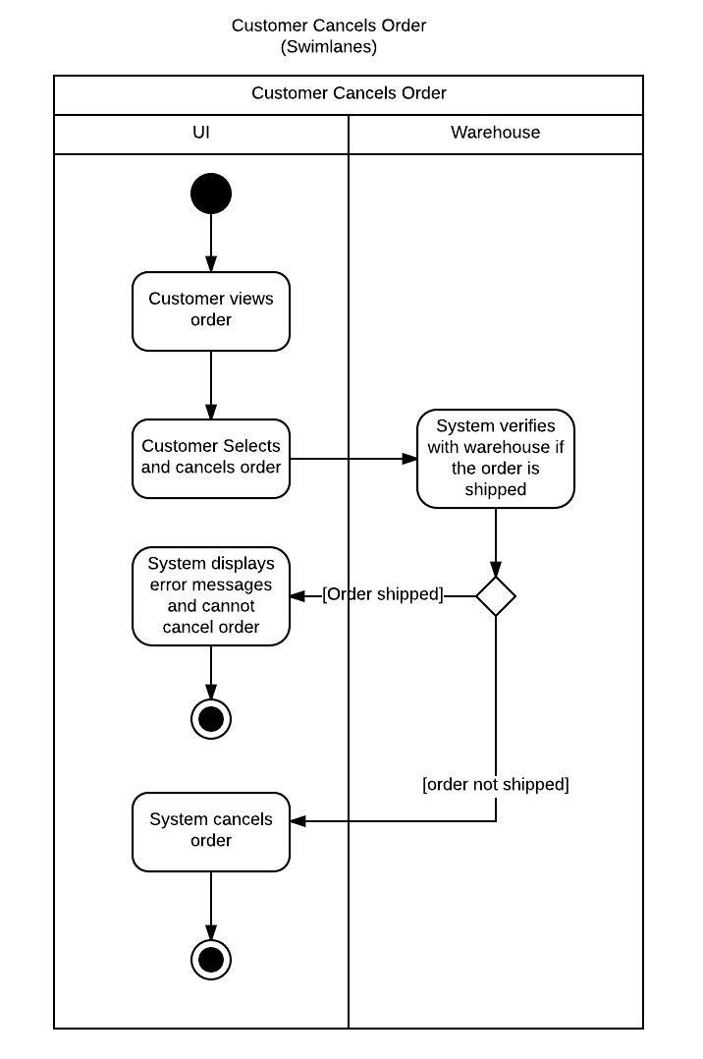

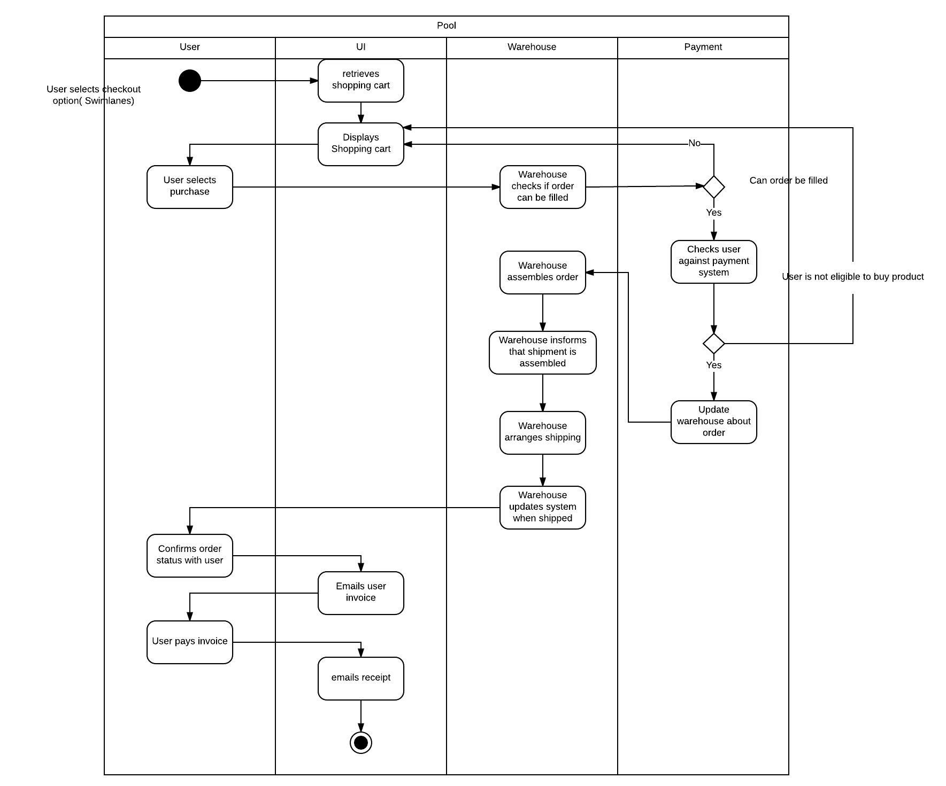

# Part B –Analysis and generation of Classes

1. Brainstorm and provide the candidate list of domain objects and an analysis showing the selection of the final list of domain objects.

|  |  |  |  |
| --- | --- | --- | --- |
| Candidate Noun | Business Meaning | Is a Class? | Justification |
| Warehouse | Tracks and handles inventory | No | External system |
| Payment System | Handles payment options | No | External system |
| UI | Interface for user | Yes | Contains interface elements |
| User | Customer | Yes | Contains information on the customer |
| Shipping System | Order delivery | No | External system |
| Order | A set of complete purchases | Yes | Contains all information on purchases and user |
| Shopping Cart | A set of purchases | No | It is just an incomplete order. |
| Invoice | A final bill of purchases | No | Derived from order |

1. Role play the classes using the steps you listed in question 1. Fill out the CRC’s, once you and your team are satisfied with the CRC’s copy them to the tables below:

|  |  |
| --- | --- |
| **Class**: UI | |
| **Responsibilities** | **Collaborators** |
|  |  |
|  |  |
|  |  |
|  |  |

|  |  |
| --- | --- |
| **Class**: User | |
| **Responsibilities** | **Collaborators** |
|  |  |
|  |  |
|  |  |
|  |  |

|  |  |
| --- | --- |
| **Class**: Order | |
| **Responsibilities** | **Collaborators** |
|  |  |
|  |  |
|  |  |
|  |  |

# Part C – Capture and Formal Documentation of Classes

This is an individual component of the assignment.

1. Capture your Classes in a Class diagram showing all public methods and relevant attributes.

Class Diagram:

Insert Class Diagram here:

1. Capture how your classes interact to accomplish their function in Sequence diagrams that shows all the functionality covered in the Activity diagrams of Part A.

Insert Sequence Diagrams here:

# Part D – Assignment and Team assessment

1. What did you learn in completing this assignment?
2. What did you have difficulty with?
3. What did you do well?
4. How many hours did you spend in completing this assignment?
5. What took you the most time?

Team Assessment

**Teamwork Evaluation**

**Project**: *420-E21-A02*

|  |  |  |  |  | **Team Member** | | | |
| --- | --- | --- | --- | --- | --- | --- | --- | --- |
| **Category** | **Exceptional (4)** | **Acceptable (3)** | **Amateur (2)** | **Unsatisfactory (1)** | **Name** | **Name** | **Name** | **Name** |
| **clearContributions** | Routinely provides useful ideas. A leader who contributes a lot of effort. | Usually provides useful ideas. A strong group member who tries hard! | Sometimes provides useful ideas. A satisfactory group member who does what is required. | Rarely provides useful ideas. May refuse to participate. |  |  |  |  |
| **clearProblem-solving** | Actively looks for and suggests solutions to problems. | Refines solutions suggested by others. | Does not suggest or refine solutions, but is willing to try out solutions suggested by others. | Does not try to solve problems or help others solve problems. Lets others do the work. |  |  |  |  |
| **clearAttitude** | Is never publicly critical of the project or the work of others. Always has a positive attitude about the task(s). | Is rarely publicly critical of the project or the work of others. Often has a positive attitude about the task(s). | Is occasionally publicly critical of the project or the work of other members of the group. Usually has a positive attitude about the task(s). | Is often publicly critical of the project or the work of other members of the group. Is often negative about the task(s). |  |  |  |  |
| **clearFocus on the task** | Consistently stays focused on the task and what needs to be done. Very self-directed. | Focuses on the task and what needs to be done most of the time. Others can count on this person. | Focuses on the task and what needs to be done some of the time. Others must sometimes nag, prod, and remind to keep this person on-task. | Rarely focuses on the task and what needs to be done. Lets others do the work. |  |  |  |  |
| **clearWorking with Others** | Almost always listens to, shares with, and supports the efforts of others. Tries to keep people working well together. | Usually listens to, shares, with, and supports the efforts of others. Does not cause "waves" in the group. | Often listens to, shares with, and supports the efforts of others, but sometimes is not a good team member. | Rarely listens to, shares with, and supports the efforts of others. Often is not a good team player. |  |  |  |  |
| **Total** |  |  |  |  |  |  |  |  |

|  |  |
| --- | --- |
| **Name** | **Comments** |
|  |  |
|  |  |
|  |  |
|  |  |

Mark Breakdown:

|  |  |
| --- | --- |
| Part A – Text steps of Use Cases |  |
| Browse Catalog + Extensions | 10 |
| View Shopping Cart + extensions | 10 |
| View Order + extension | 10 |
| Provide Ratings | 5 |
| Write Reviews | 5 |
| Activity Diagrams | 20 |
| Part B – Analyze for classes | 5 |
| CRCs | 15 |
| Part C – UML for Classes |  |
| Class Diagrams | 20 |
| Sequence Diagrams | 20 |
| Part D – Assessment, English, properly handed in | 7 |

**To submit**

The following must be submitted to Moodle by each student:

* All diagrams completed in LucidChart and pasted in this document. All diagrams MUST have an author’s name indicating who drew the diagram.
* Your diagrams must be consistent with each other and your model. That is, your list of classes and their methods must be able to express the behavior in the sequence diagrams.
* Submit Parts A, B to the Team submission folder for this assignment.
* Submit Part C,D to the Individual submission folder.

# Appendix A: Use case Notes

**External Systems**

You may choose to add an external system for:

1. Payment processing
2. Order processing
3. Shipping

If you would like to add any other external systems, please get approval from your professor first.

**Business rules**

Orders

Customers can only cancel complete orders, that is, you can not cancel portions of an order. All items in a single order are shipped together.

Customers are only billed after an order is shipped.

Customers may cancel an order providing that it hasn’t shipped yet.

An order has the following states:

1. Pending assembly – order is being assembled
2. Pending Shipment – order is ready and awaiting shipment
3. Shipped – order is in the process of being shipped
4. Delivered – confirmation from the shipping company that the product has been delivered
5. Closed – order has been paid for and delivered.